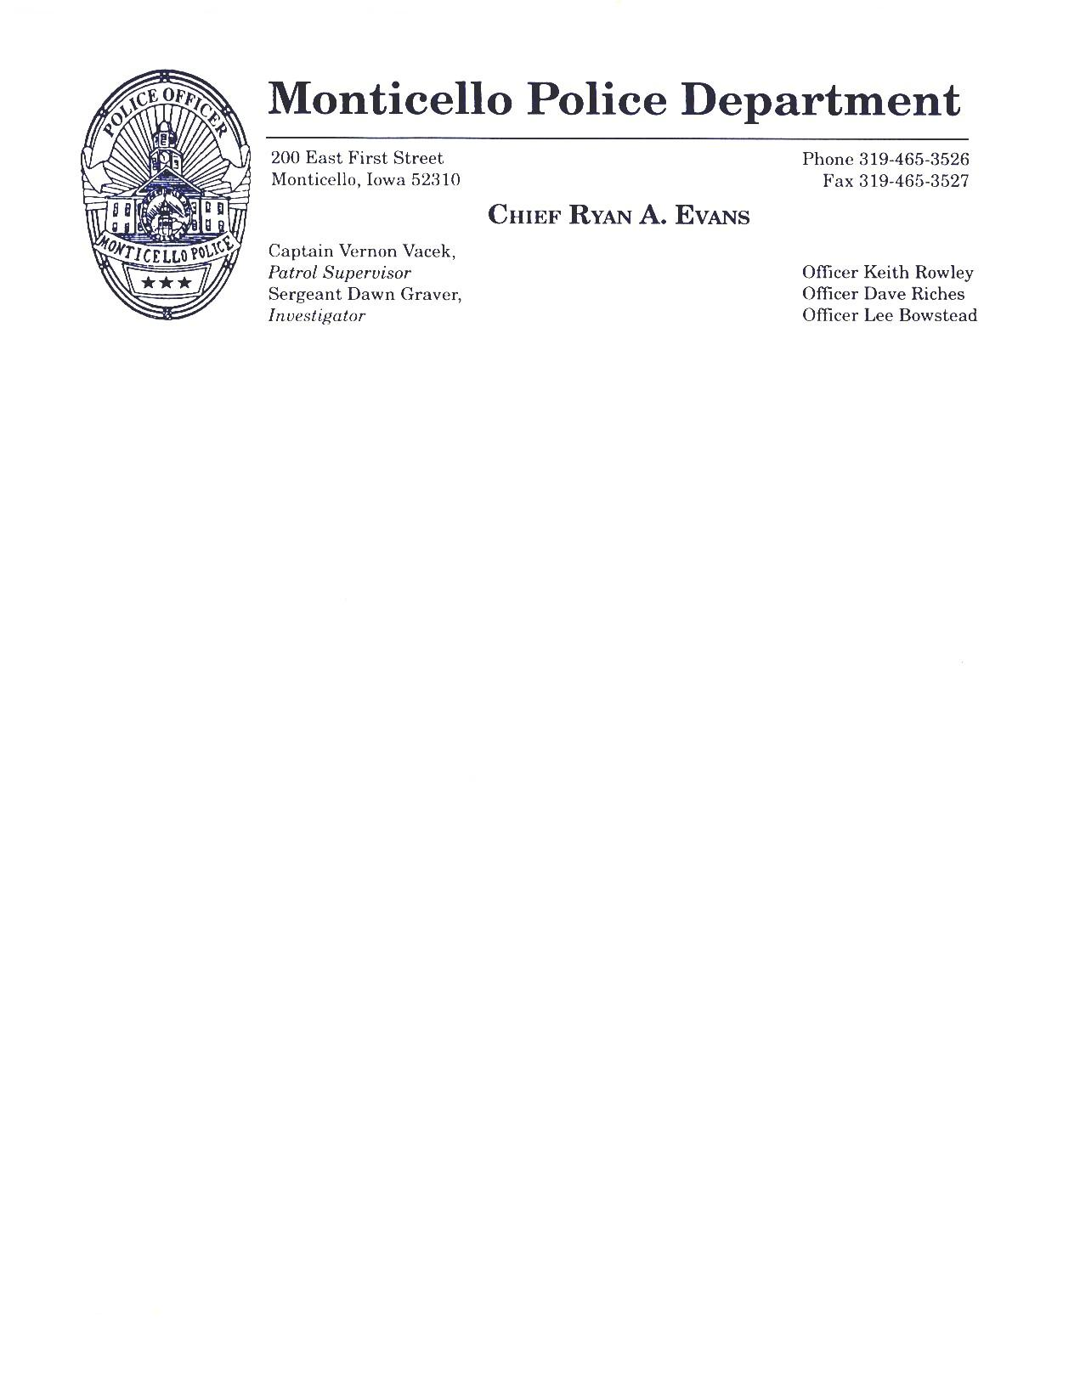

201 East South Street

**Police Chief Britt Smith**

**Sergeant Dawn Graver**

Officer Brian Tate Officer Bob Urbain

Officer Jordan Koos



4681

#### Fax 319-465-4681

# Officer Dave Riches

### Officer Lee Bowstead

## Officer Don Kinney

Employment Notice/Police Officer

The Monticello Police Department is accepting applications for the position of Full-Time Police Officer. Applications may be picked up at the Monticello Police Department, 201 East South Street Monticello, IA or downloaded from the City of Monticello website at [www.ci.monticello.ia.us/city-departments/police](http://www.ci.monticello.ia.us/city-departments/police)

Application deadline is Friday, July 31st at 4:30pm. Applications will be reviewed and successful applicants will be notified and invited to complete the physical agility testing and written exam on Saturday, August 22nd , 2015 at 10:00am. Lateral transfers for current ILEA certified officers with no lapse in employment will be considered and pay rates based upon previous years of experience. For further information regarding the testing process, compensation, and benefits please visit the City of Monticello Police Department Website.

The City of Monticello is an equal opportunity employer.